**VPM's K.G. Joshi College of Arts and N.G. Bedekar College of Commerce (Autonomous), Thane**

**Activity Report**

**1. Title of the activity – मूल्यवर्धित अभ्यासक्रम Value Added Course in 30hrs. Internship**

**2. Name of the Departments - Department of Sanskrit**

**3. Day and Date -1st August to 14th August**

**4. Name of Resource Person - Mrs. Rupali Pradhan**

**5. No. of students benefited - Male -2 Female-12 Total-14**

**6. Purpose of the Activity:The purpose of this course is to raise awareness and equip students with practical skills in the preservation, restoration, and documentation of ancient manuscripts and texts, commonly known as *pothis*. These texts, often handwritten on palm leaves, handmade paper, or bark, hold immense cultural, literary, and historical value.**

**By offering this course, the college aims to:**

* **Promote cultural heritage awareness among students.**
* **Prevent the loss of valuable traditional knowledge due to neglect, decay, or improper handling.**
* **Encourage interdisciplinary learning that combines history, literature, archival science, and technology.**
* **Provide hands-on experience in the basic methods of manuscript preservation and digitization.**
* **Inspire students to take active roles in conserving their own family, temple, or community texts.**

**This course not only strengthens academic learning but also contributes to cultural conservation efforts at a grassroots level.**

**Gist of Activity :- This add-on course is designed to educate and train students in the preservation and protection of ancient handwritten manuscripts and traditional texts (pothis). The course introduces students to the historical and cultural significance of these texts and equips them with basic conservation techniques, safe handling practices, and digitization methods.**

**Through practical workshops, lectures, and project work, the course aims to create awareness, build skills, and encourage cultural responsibility among students in safeguarding India's literary heritage.**

**Teacher Incharge :- Asst. Prof. Rohini Joshi**

**Thanks and Regards**

**Asst. Prof. Swati M. Bhalerao  Dr. Suchitra A. Naik**

**HoD Sanskrit Principal**

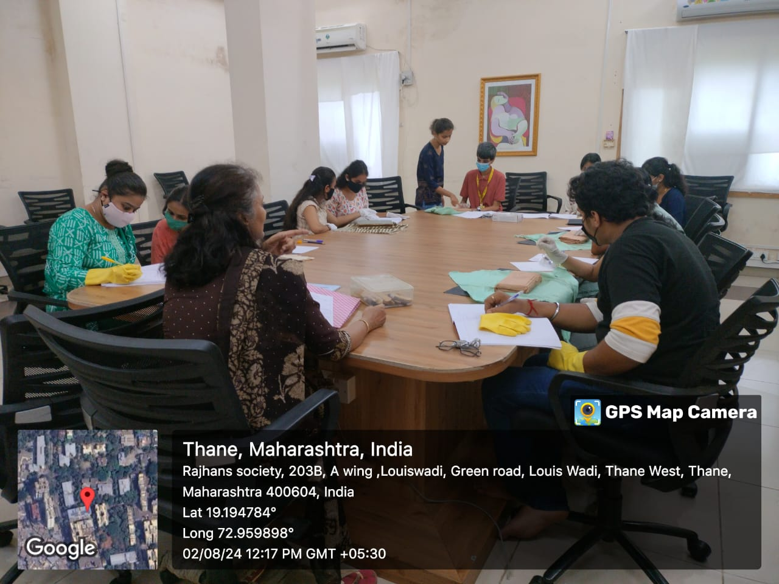

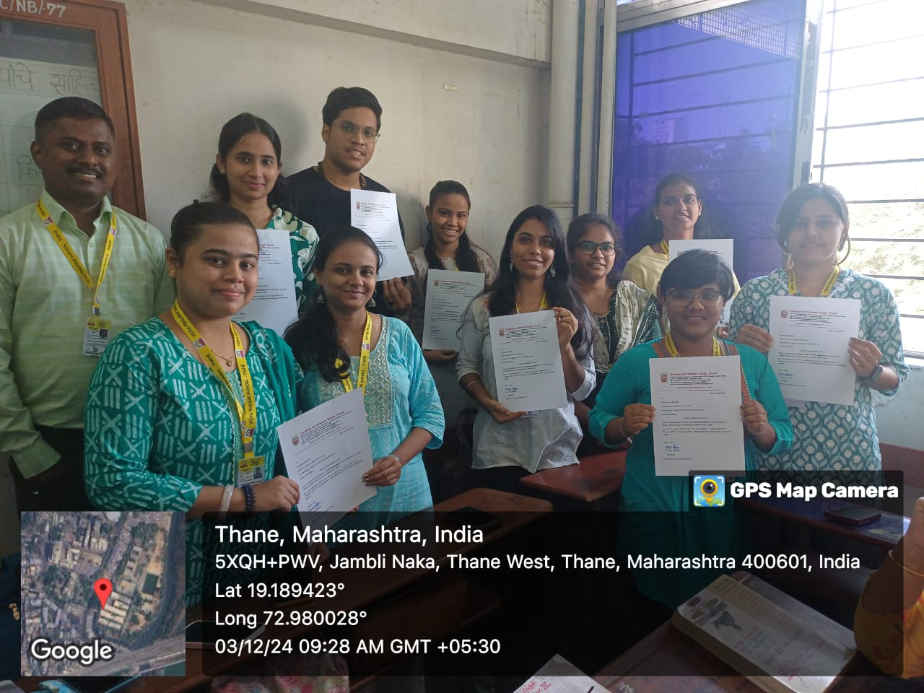

**मूल्यवर्धित अभ्यासक्रम Value Added Course in 30hrs. Internship**